ICT ACADEMY OF KERALA
Summer Internship Report

Full Stack Application Development

with ReactJS


Name of Team Members:
1. Sreejith S
2. Rithwik Dev
3. Divek D
4. Ajith N
Name of Your Institution: Yuvakshetra Institute of Management Studies (YIMS)
25-6-2026

EXECUTIVE SUMMARY

The Blood Bank Management System is a web-based application developed to facilitate efficient management of blood donors and blood requests. The project aims to bridge the gap between blood donors and recipients by providing a centralized platform for managing donor information, blood availability, and emergency blood requests.

The system was developed using modern web technologies including React.js for the frontend, Node.js and Express.js for the backend, and MongoDB as the database. The project provides functionalities such as user registration and login, donor management, blood request submission, request tracking, and administrative approval processes.

The successful implementation of the project demonstrates the practical application of full-stack web development concepts while addressing a real-world healthcare need. The system improves the efficiency of blood donation management and helps streamline communication between donors, recipients, and administrators.

INTRODUCTION

Blood donation plays a critical role in healthcare services, especially during emergencies and medical procedures. Traditional methods of maintaining donor records and handling blood requests are often manual, time-consuming, and prone to errors. Therefore, there is a need for a digital platform that can efficiently manage donor information and blood requests.

The Blood Bank Management System was developed to provide an organized and user-friendly solution for blood donation management. The system enables users to register, view available donors, submit blood requests, and receive updates regarding their requests. Administrators can manage donor records and process blood requests efficiently.

Several existing studies and healthcare systems have highlighted the importance of digital blood bank solutions in reducing response times and improving accessibility. Inspired by these findings, this project was designed to create a simple yet effective platform that supports blood donation activities and emergency blood requirements.

OBJECTIVES

1. To develop a web-based Blood Bank Management System.

2. To create a secure user registration and login mechanism.

3. To manage donor information efficiently using a centralized database.

4. To facilitate blood request submission and tracking.

5. To provide administrative tools for managing donors and requests.

6. To enhance practical knowledge of full-stack web development.

7. To gain experience with database management and API development.

8. To improve teamwork, problem-solving, and project management skills.

SCOPE AND DELIVERABLES

Scope:

* User registration and authentication.

* Blood donor management.

* Blood request management.

* Administrative dashboard for system monitoring.

* Request approval and rejection functionality.

* Notification system for users.

* Database storage and retrieval of donor and request information.

Deliverables

Software Components:

* Frontend Web Application (React.js)

* Backend REST API (Node.js & Express.js)

* MongoDB Database

METHODOLOGY

The project was developed using a structured software development approach.

1. Requirement Analysis

The project requirements were collected and analyzed to identify the needs of blood donors, recipients, and administrators.

2. System Design

The system architecture, database schema, user interfaces, and API endpoints were designed before implementation.

3. Frontend Development

The frontend was developed using:

React.js,React Router, Material UI,Axios,Vite

User-friendly interfaces were created for registration, login, donor management, and blood requests.

4. Backend Development

The backend was implemented using:

Node.js, Express.js, MongoDB,Mongoose,API

5. Testing

The application was tested to ensure:

* Proper user authentication

* Accurate data storage and retrieval

* Correct request processing

* Smooth navigation and functionality

6. Deployment Preparation

The final version was documented and prepared for deployment and future enhancement.

PROJECT ACTIVITIES

Activity 1: Database Design

Created MongoDB collections for:

Users,Donors, Blood Requests

Activity 2: User Authentication Module

Implemented:

* User Registration

* User Login

* Session Navigation

Activity 3: Donor Management

Developed features to:

* Add Donors

* View Donors

* Update Donor Information

* Delete Donor Records

Activity 4: Blood Request Management

Implemented functionality to:

* Submit Blood Requests

* View Request Status

* Track Notifications

Activity 5: Admin Dashboard

Created an administrative dashboard to:

* Manage donor records

* View blood requests

* Approve requests

* Reject requests

Activity 6: Frontend Development

Designed responsive user interfaces using Material UI components and React.

Activity 7: API Development

Created REST APIs including:

* POST /signup

* POST /login

* GET /donors

* POST /donor

* PUT /donor/edit/

* DELETE /donor/remove/

* POST /request

* GET /requests

* PUT /request/

RESULTS & FINDINGS

Results

The Blood Bank Management System was successfully developed and tested.

Functional Achievements

✔️ User Registration and Login System

✔️ Donor Management Module

✔️ Blood Request Submission

✔️ Request Approval and Rejection

✔️ Notification System

✔️ MongoDB Database Integration

✔️ REST API Communication

Key Findings

* Digital blood bank systems significantly improve record management.

* Centralized donor information increases accessibility.

* Automated request tracking improves efficiency.

* Full-stack development provides seamless integration between frontend and backend systems.

System Architecture

Frontend (React.js)-Axios API Calls-Backend (Node.js + Express.js)-MongoDB Database

CONCLUSION
The Blood Bank Management System was successfully designed and developed during the internship period. The project achieved all its primary objectives by providing an efficient platform for donor management and blood request processing.The internship offered valuable hands-on experience in full-stack web development, database management, API development, and user interface design. It enhanced technical competencies in React.js, Node.js, Express.js, and MongoDB while improving teamwork and problem-solving abilities.The completed system demonstrates how technology can be effectively used to support healthcare services and improve the management of blood donation activities..

APPENDIX
Appendix A – Software Requirements
* Node.js
* MongoDB
* React.js
* Vite
* Visual Studio Code
Appendix B – Project Folder Structure
project fr/
├── backend/
│ ├── models/
│ │ ├── Donor.js
│ │ ├── Request.js
│ │ └── User.js
│ ├── routes/
│ │ ├── auth.js
│ │ ├── donor.js
│ │ ├── request.js
│ │ └── user.js
│ ├── connection.js
│ ├── index.js
│ ├── package-lock.json
│ └── package.json
└── blood-bank/
├── public/
│ ├── favicon.svg
│ └── icons.svg
├── src/
│ ├── assets/
│ │ ├── hero.png
│ │ ├── react.svg
│ │ └── vite.svg
│ ├── components/
│ │ └── Navbar.jsx
│ ├── pages/
│ │ ├── AdminDashboard.jsx
│ │ ├── AdminOverview.jsx
│ │ ├── AdminReceiverList.jsx
│ │ ├── AdminUserList.jsx
│ │ ├── Admindonor.jsx
│ │ ├── Adminrequest.jsx
│ │ ├── Adminusers.jsx
│ │ ├── DonorDashboard.jsx
│ │ ├── Profile.jsx
│ │ ├── home.jsx
│ │ ├── login.jsx
│ │ └── signup.jsx
│ ├── App.css
│ ├── App.jsx
│ ├── index.css
│ └── main.jsx
├── .gitignore
├── README.md
├── eslint.config.js
├── index.html
├── package-lock.json
├── package.json
└── vite.config.js
Appendix C – API Endpoints
Method Endpoint Description
POST /signup User Registration
POST /login User and Admin Authentication
PUT /api/profile User Profile Update (Requires Bearer Token)
POST /api/contact Submit Contact Support Query
GET /donors Retrieve All Active Donors
POST /donors Create New Active Donor Record
PUT /api/donors/:id Update Donor Profile (Admins Only)
DELETE /api/donors/:id Delete Donor Profile (Admins Only)
DELETE /donors/:id Legacy Public Delete Donor
GET /requests Retrieve All Blood Request Tickets
POST /request Submit Blood Request / Donation Ticket
PUT /requests/:id Approve or Reject Blood Ticket (Approve auto-creates donor)
GET /api/users Retrieve All Registered User Accounts (Admins Only)
PUT /api/users/:id Update User Account Status/Details (Admins Only)

Appendix D – Screenshots
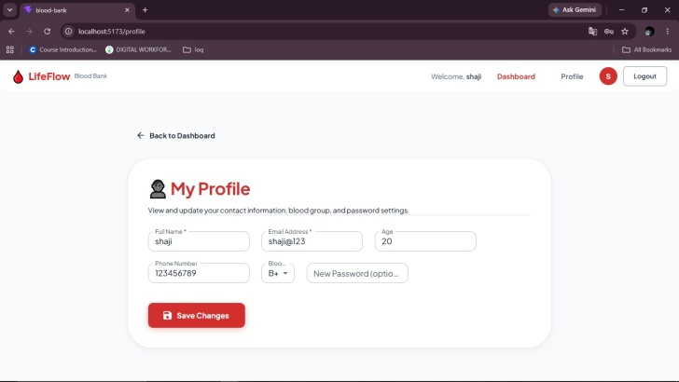
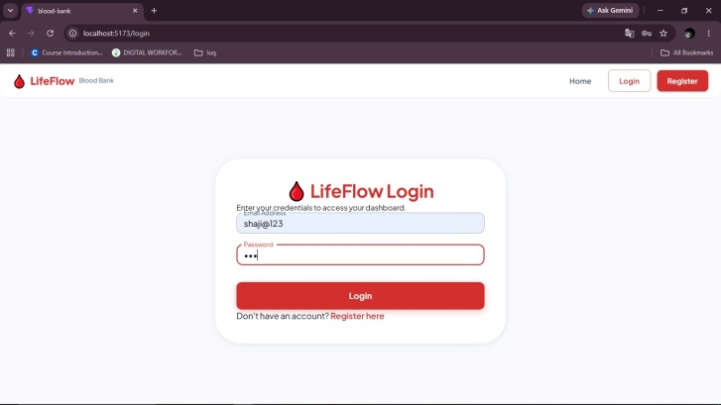
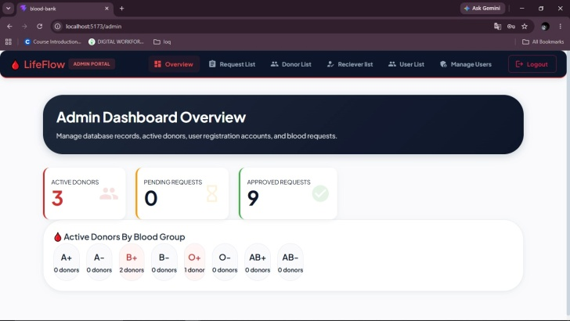
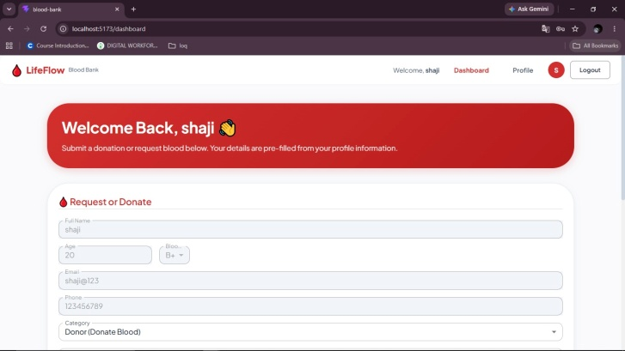

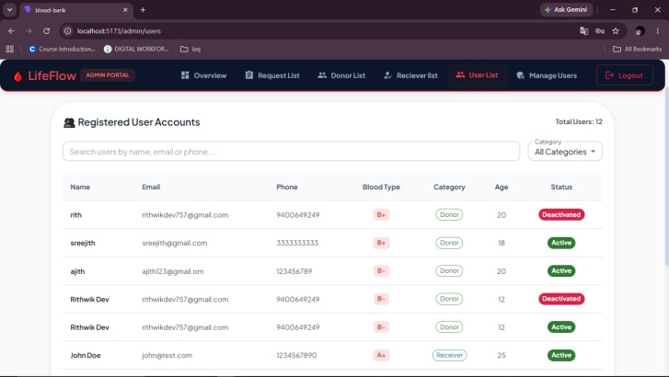
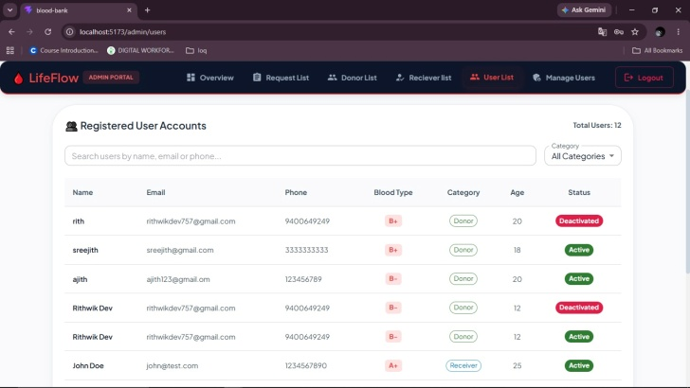

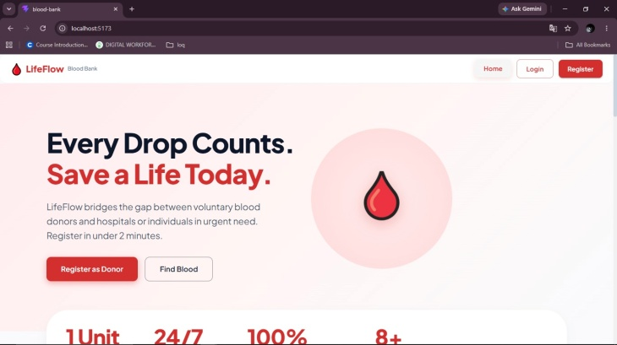
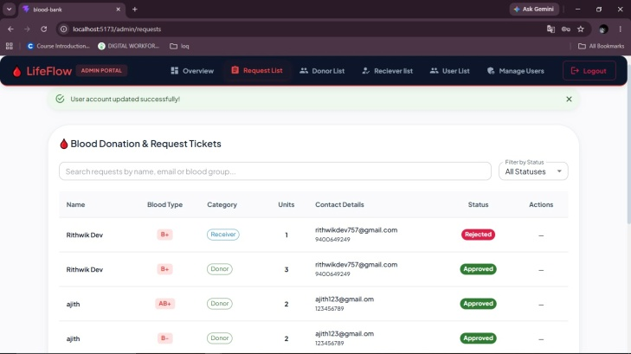
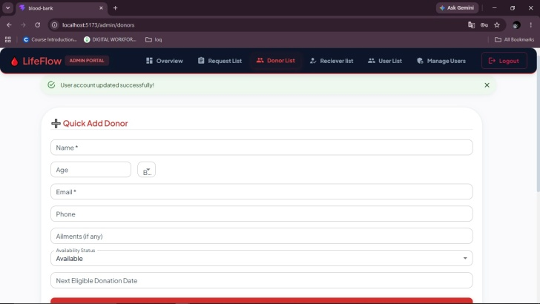
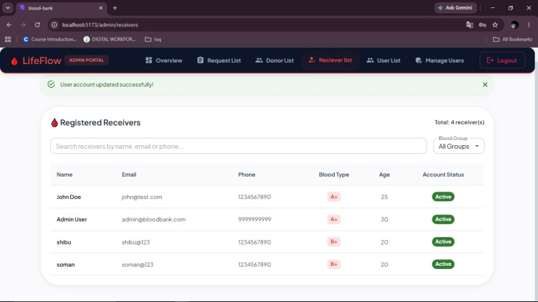

References
1. React.js Documentation
2. Node.js Documentation
3. Express.js Documentation
4. MongoDB Documentation
5. Material UI Documentation
6. Axios Documentation

